# JS Advanced: Exam Preparation 1

**Link to contest**: <https://alpha.judge.softuni.org/contests/js-advanced-retake-exam-02-august-2023/4225>

**Problem 1. Fitness Journey**

**Environment Specifics**

Please be aware that every JS environment may **behave differently** when executing code. Certain things that work in the browser are not supported in **Node.js**, which is the environment used by **Judge**.

The following actions are **NOT** supported:

* **.forEach()** with **NodeList** (returned by **querySelector()** and **querySelectorAll()**)
* **.forEach()** with **HTMLCollection** (returned by **getElementsByClassName()** and **element.children**)
* Using the **spread-operator** (**...**) to convert a **NodeList** into an array
* **append()** in Judge (use only **appendChild()**)
* **prepend()**
* **replaceWith()**
* **replaceAll()**
* **closest()**
* **replaceChildren()**
* Always turn the collection into a **JS array** (forEach, forOf, et.)

If you want to perform these operations, you may use **Array.from()** to first convert the collection into an array.

**Use the provided skeleton to solve this problem.**

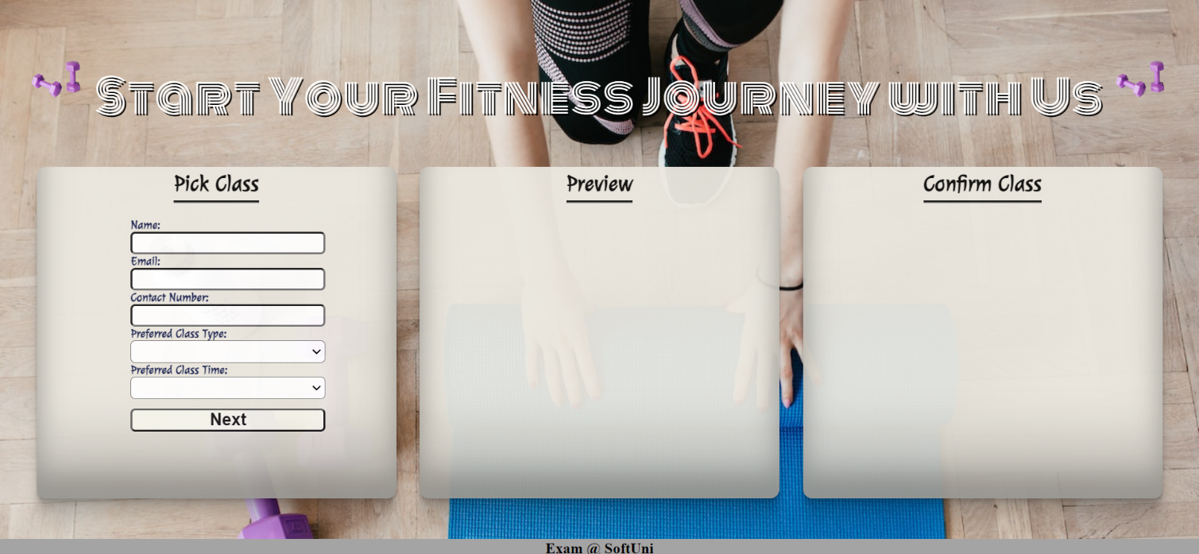**Write the missing functionality** of this user interface. The functionality is divided in the following steps:

## Your Task

**Write the missing JavaScript code** to make the **Fitness Journey** work as expected:

All fields **(Name, Email, Contact Number, Preferred Class** and **Class Time)** are **filled with the correct input.**

* **Name, Email, Contact Number, Preferred Class** and **Class Time** are **non**-**empty** **strings.** If any of them is empty, the program should not do anything.

**Getting the information from the form**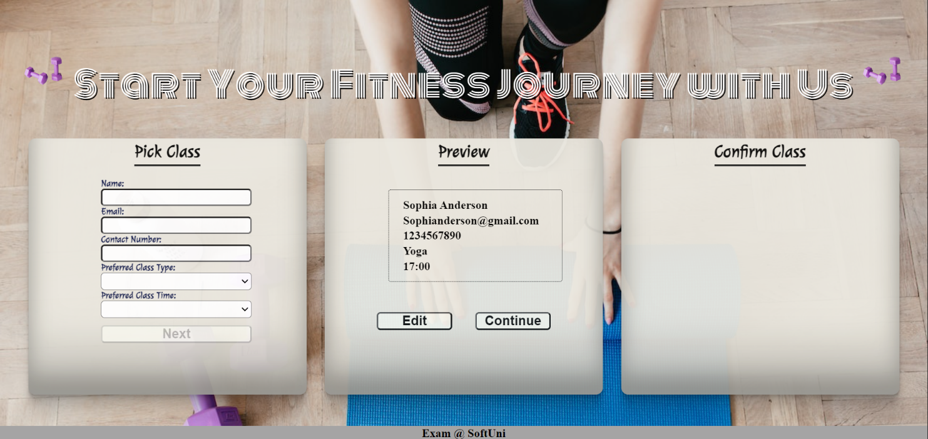

* On clicking the **["Next"]** button the information from the input fields is listed in the **"preview-section"** section. For the input fields a **list item** is **added** to the **"class-info"** unordered list.
* The text format and order for the list item should be the same as on the picture below.
* When the button is clicked, the input fields must be cleared and the **["Next"]** button must be **disabled**. At the same time the **"Edit"** and the **"Continue"** buttons must be **added**.

The HTML structure looks like this:

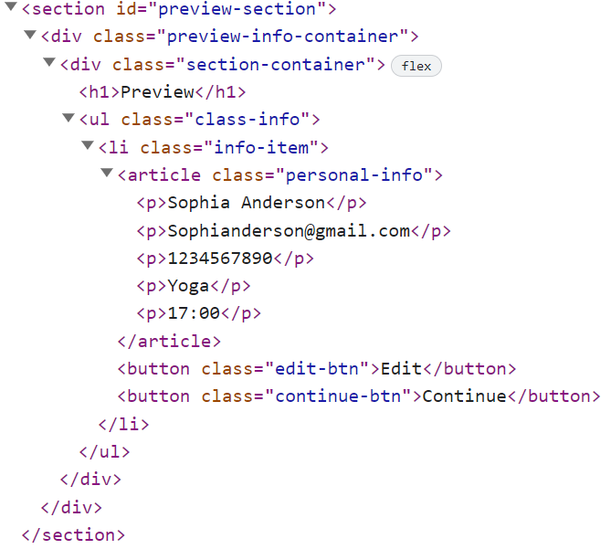

**Edit**

* **When the "Edit" button is clicked, all of the information is loaded in the input fields from step 1 and the ["Next"] button is enabled again.**

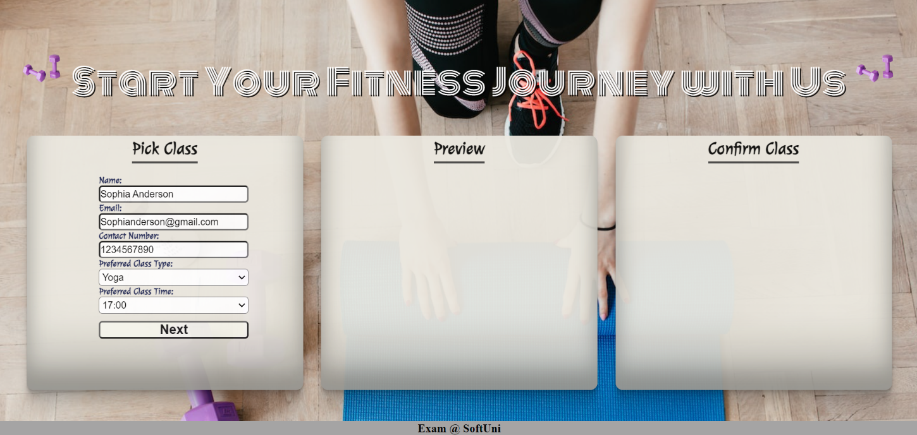

* **The list item must be removed from the "class-info" and all of the information must go back to the input fields again.**

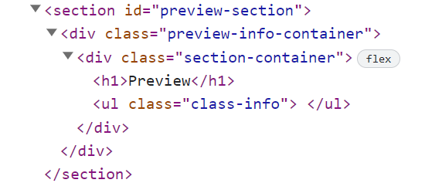

**Continue**

* **When the "Continue" button is clicked,** **the information from "class-info"** unordered list must be transferred to **"confirm-class"** in the **same** HTML structure**. For you, this means removing everything inside of the ul with class "class-info" and adding in "confirm-class"**, **the list item with same information and class "continue-info" , delete "Edit"** and **"Continue"** buttons and **add** new buttons **"Confirm"** and **"Cancel"** with **class "confirm-btn"** and **"cancel-btn"** .

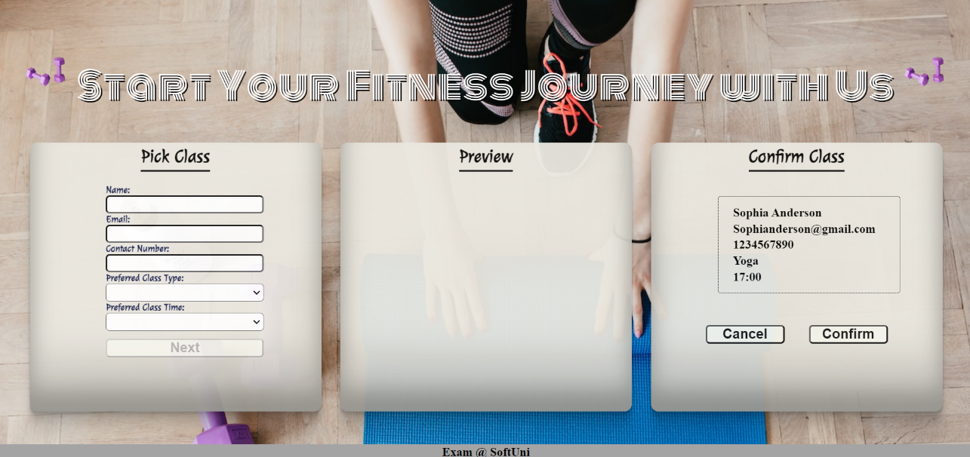

* **This is the HTML** structure **of "confirm-class"** unordered list**:**

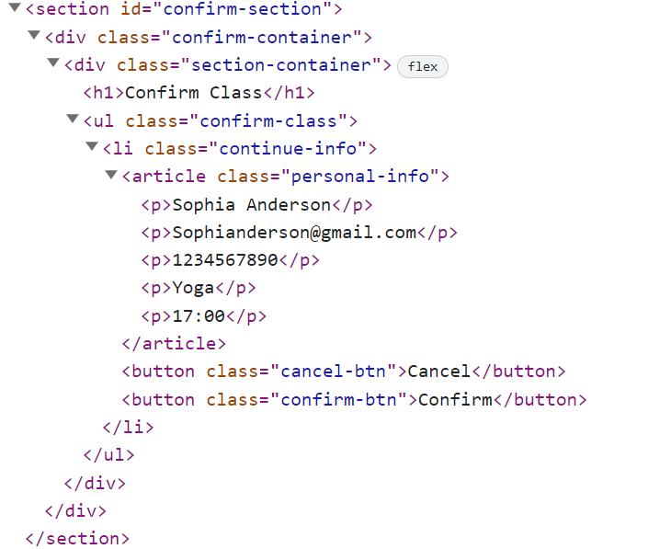

**Cancel**

* **When the "Cancel" button is clicked,** **the list item must be removed, from the "confirm-class", the ["Next"] button is enabled again.**

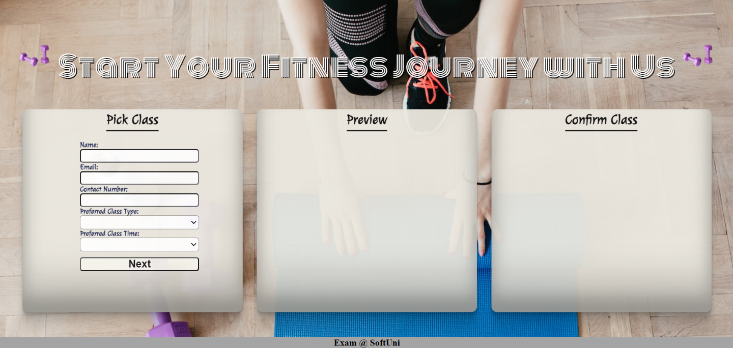

**Confirm**

* **When the "Confirm" button is clicked,** **the <div> element with id="main" must be removed, from the body** andyoumust **add <h1>** element with id=**"thank-you"** and **text "Thank you for scheduling your appointment, we look forward to seeing you!"** and **<button>** with id=**"done-btn"** and **text "Done".**



The HTML structure looks like this:

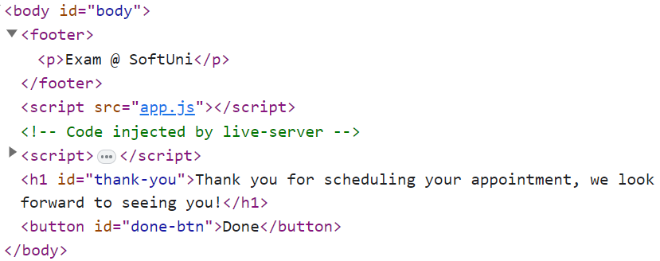

* On clicking the **["Done"]** button you must **reload** the page.

## Submission

Submit only your **solution()** function.

**Problem 2. Inventory Management**

class InventoryManager {

//TODO Implement this class

}

Write a class **InventoryManager**, which implements the following functionality:

**Functionality**

**Constructor**

Should have these **3** properties:

* **capacity –** Number
* **items –** Array (empty)
* **outOfStock –** Array (empty)

**At the initialization of the InventoryManager class,** the **constructor** accepts the **capacity.**

#### addItem(itemName, quantity)

* This method should allow adding items to the inventory. It accepts two parameters: **itemName** (string) and **quantity** (number).
* If the quantity is **less** **than** or **equal** to 0**, throw an error** with the message:

**"Quantity must be greater than zero."**

* If the inventory is already full (reached the **capacity**), **throw an error** with the message:

**"The inventory is already full."**

* If the item already exists in the inventory, increase the **quantity** of the existing item by the specified quantity. Otherwise, add a new item with the **itemName** and **quantity** to the items array.
* **Return** a string message in the format:

**"Added {quantity} {itemName}(s) to the inventory."**

#### sellItem(itemName, quantity)

* This method should allow selling items from the inventory. It accepts two parameters: **itemName** (string) and **quantity** (number).
* If the **quantity** is **less** than or **equal** to 0, **throw an error** with the message:
  + - 1. **"Quantity must be greater than zero."**
* If the item does not exist in the inventory, **throw an error** with the message:

**"The item {itemName} is not available in the inventory."**

* If the **quantity** requested is **greater** than the available **quantity** of the item in the inventory**, throw an error** with the message:

**"Not enough {itemName}(s) in stock."**

* **Decrease** the **quantity** of the item in the inventory by the specified **quantity**.
* If the **quantity** of the item becomes 0 after selling, remove the item from the items array and add the **itemName** to the **outOfStock** array.
* **Return** a string message in the format:

**"Sold {quantity} {itemName}(s) from the inventory."**

#### restockItem(itemName, quantity)

* This method should allow restocking items in the inventory. It accepts two parameters: **itemName** (string) and **quantity** (number).
* If the **quantity** is **less** than or **equal** to 0, **throw an error** with the message:

**"Quantity must be greater than zero."**

* If the item already **exists** in the inventory, **increase** the **quantity** of the existing item by the specified **quantity**. Otherwise, add a new item with the **itemName** and **quantity** to the items array.
* If the item exists in the **outOfStock** array, remove it from the **outOfStock** array.
* **Return** a string message in the format:

**"Restocked {quantity} {itemName}(s) in the inventory."**

#### getInventorySummary()

* This method should **return** a summary of the current inventory.
* The summary should be a **string** with the following format:
* On the first line:

**"Current Inventory:"**

* For each item in the items array, **add** a line in the format:

**"{itemName}: {quantity}**"

* If there are items in the **outOfStock** array, add a line in the format:

**"Out of Stock: {itemName1}, {itemName2}**" (comma-separated list of item names)

### Examples

|  |
| --- |
| **Input 1** |
| const manager = new InventoryManager(2);  console.log(manager.addItem("Drill", 10));  console.log(manager.addItem("Hammer", 5));  console.log(manager.addItem("Level", 3)); |

|  |
| --- |
| **Output 1** |
| Added 10 Drill(s) to the inventory.  Added 5 Hammer(s) to the inventory.  Uncaught Error Error: The inventory is already full. |

|  |
| --- |
| **Input 2** |
| const manager = new InventoryManager(3);  console.log(manager.addItem("Drill", 10));  console.log(manager.addItem("Hammer", 5));  console.log(manager.addItem("Chisel", 3));  console.log(manager.sellItem("Drill", 3));  console.log(manager.sellItem("Paintbrush", 2)); |

|  |
| --- |
| **Output 2** |
| Added 10 Drill(s) to the inventory.  Added 5 Hammer(s) to the inventory.  Added 3 Chisel(s) to the inventory.  Sold 3 Drill(s) from the inventory.  Uncaught Error Error: The item Paintbrush is not available in the inventory. |

|  |
| --- |
| const manager = new InventoryManager(3);  console.log(manager.addItem("Drill", 10));  console.log(manager.addItem("Hammer", 5));  console.log(manager.addItem("Chisel", 3));  console.log(manager.sellItem("Drill", 3));  console.log(manager.restockItem("Drill", 5));  console.log(manager.restockItem("Paintbrush", 1)); |

|  |
| --- |
| **Output 3** |
| Added 10 Drill(s) to the inventory.  Added 5 Hammer(s) to the inventory.  Added 3 Chisel(s) to the inventory.  Sold 3 Drill(s) from the inventory.  Restocked 5 Drill(s) in the inventory.  Restocked 1 Paintbrush(s) in the inventory. |

|  |
| --- |
| **Input 4** |
| const manager = new InventoryManager(3);  console.log(manager.addItem("Drill", 10));  console.log(manager.addItem("Hammer", 5));  console.log(manager.addItem("Chisel", 3));  console.log(manager.sellItem("Drill", 3));  console.log(manager.sellItem("Hammer", 5));  console.log(manager.restockItem("Drill", 5));  console.log(manager.restockItem("Paintbrush", 1));  console.log(manager.getInventorySummary()); |

|  |
| --- |
| **Output 4** |
| Added 10 Drill(s) to the inventory.  Added 5 Hammer(s) to the inventory.  Added 3 Chisel(s) to the inventory.  Sold 3 Drill(s) from the inventory.  Sold 5 Hammer(s) from the inventory.  Restocked 5 Drill(s) in the inventory.  Restocked 1 Paintbrush(s) in the inventory.  Current Inventory:  Drill: 12  Chisel: 3  Paintbrush: 1  Out of Stock: Hammer |

**Problem 3. Recipe Selection**

**Your Task**

Using **Mocha** and **Chai** write **JS Unit Tests** to test a variable named **recipeSelection**, which represents an object. You may use the following code as a template:

|  |
| --- |
| describe(**"*Tests* …"**, **function**() {  describe(**"*TODO* …"**, **function**() {  ***it***(**"*TODO …*"**, **function**() {  *//* ***TODO:*** …  });  });  *//* ***TODO:*** …  }); |

The object that should have the following functionality:

* **isTypeSuitable(type, dietaryRestriction)** This function determines if a recipe type is suitable for a given dietary restriction. It takes in two parameters: a **type** (**string**) representing the recipe type and a **dietaryRestriction** (**string**) representing the dietary restriction.
* If the dietaryRestriction is "**Vegetarian**" and the type is "**Meat**", it **returns** the message:

**"This recipe is not suitable for vegetarians".**

* If the **dietaryRestriction** is "**Vegan**" and the type is either "**Meat**" or "**Dairy**", it **returns** the message:

**"This recipe is not suitable for vegans"**

* For any other combination of **type** and **dietaryRestriction**, it **returns** the message:

**"This recipe is suitable for your dietary restriction"**

* You need to validate the input, if the **type** and **dietaryRestriction** are not a **strings**, **throw** an error: "**Invalid input**".
* **isItAffordable (price, budget) -** A function that accepts two parameters: **number** and **number**.
* It **calculates** the remaining **budget** by **subtracting** the **price** from the **budget**.
* If the remaining **budget** is **less** than 0, it **returns** the message:

**"You don't have enough budget to afford this recipe"**

* Otherwise, it **returns** the message:

**"Recipe ingredients bought. You have {remainingBudget}$ left"**

* Where **remainingBudget** is the calculated value.
* You need to validate the input, if the **price** and **budget** are not a **number**, **throw** an error: "**Invalid input**".
* **getRecipesByCategory(recipes, category)** This function filters an array of **recipes** based on a desired **category** and **returns** an array of recipe titles. It takes in two parameters: **recipes** (**array**) representing the array of recipe objects and **category** (**string**) representing the desired **category.**
  + It filters the **recipes** array based on the **category** and creates a **new** array **filteredRecipes** containing only the **recipes** that match the desired **category**.
  + The **recipes** array will store the titles and the category of its recipes ([{ **title**: " Spicy Tofu Stir-Fry ", **category**: " **Asian** " }, ...])
  + It maps through the **filteredRecipes** array to extract the **titles** of the recipes and **returns** an array of these **titles**.
  + There is a need for validation for the input, an **array** and **string** may not always be valid. In case of submitted **invalid** parameters, **throw** an error "**Invalid input**":
    - If passed **recipes** parameteris not an array.
    - If the **category** is not a string.

**JS Code**

To ease you in the process, you are provided with an implementation that meets all of the specification requirements for the **recipeSelection** object:

|  |
| --- |
| recipeSelection.js |
| const recipeSelection = {    isTypeSuitable(type, dietaryRestriction) {      if (typeof type !== "string" || typeof dietaryRestriction !== "string"){        throw new Error("Invalid input");      }      if (dietaryRestriction === "Vegetarian" && type === "Meat") {        return "This recipe is not suitable for vegetarians";      } else if (dietaryRestriction === "Vegan" && (type === "Meat" || type === "Dairy")) {        return "This recipe is not suitable for vegans";      } else {        return "This recipe is suitable for your dietary restriction";      }    },    isItAffordable(price, budget) {      if (typeof price !== "number" || typeof budget !== "number") {        throw new Error("Invalid input");      }      let remainingBudget = budget - price;      if (remainingBudget < 0) {        return "You don't have enough budget to afford this recipe";      } else {        return `Recipe ingredients bought. You have ${remainingBudget}$ left`;      }    },    getRecipesByCategory(recipes, category) {      if (!Array.isArray(recipes) || typeof category !== "string") {        throw new Error("Invalid input");      }      const filteredRecipes = recipes.filter((recipe) => recipe.category === category);      return filteredRecipes.map((recipe) => recipe.title);    },  }; |

**Submission**

Submit your tests inside a **describe()** statement, as shown above.